Individual Pathways
Activity 3.2
Investigating evolution doc-8468
- Fill in the gaps in the diagram below illustrating the biological classification hierarchy initially outlined by Linnaeus. Then create your own memory aid to help you remember the order of the hierarchy (e.g. Kids Play Cheerfully On Farmer George’s Swings).  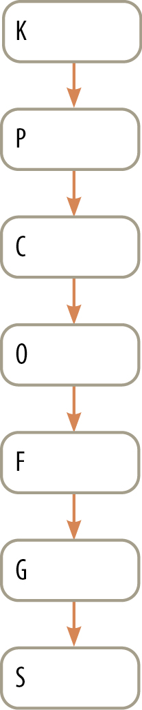 | - Fill in the gaps in the diagram below illustrating the different levels of organisation in multicellular organisms. Then create your own memory aid to help you remember the levels of organisation in multicellular organisms (e.g. My Sister’s Only Tooth Cuts Nice Donuts).  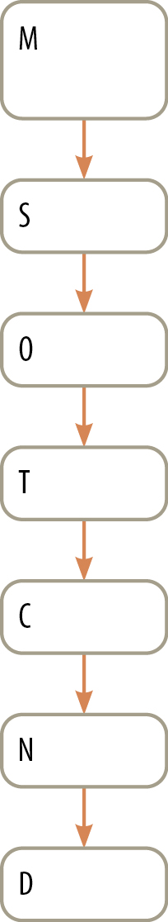

- Complete the flowchart below illustrating the relationship between different types of diversity.

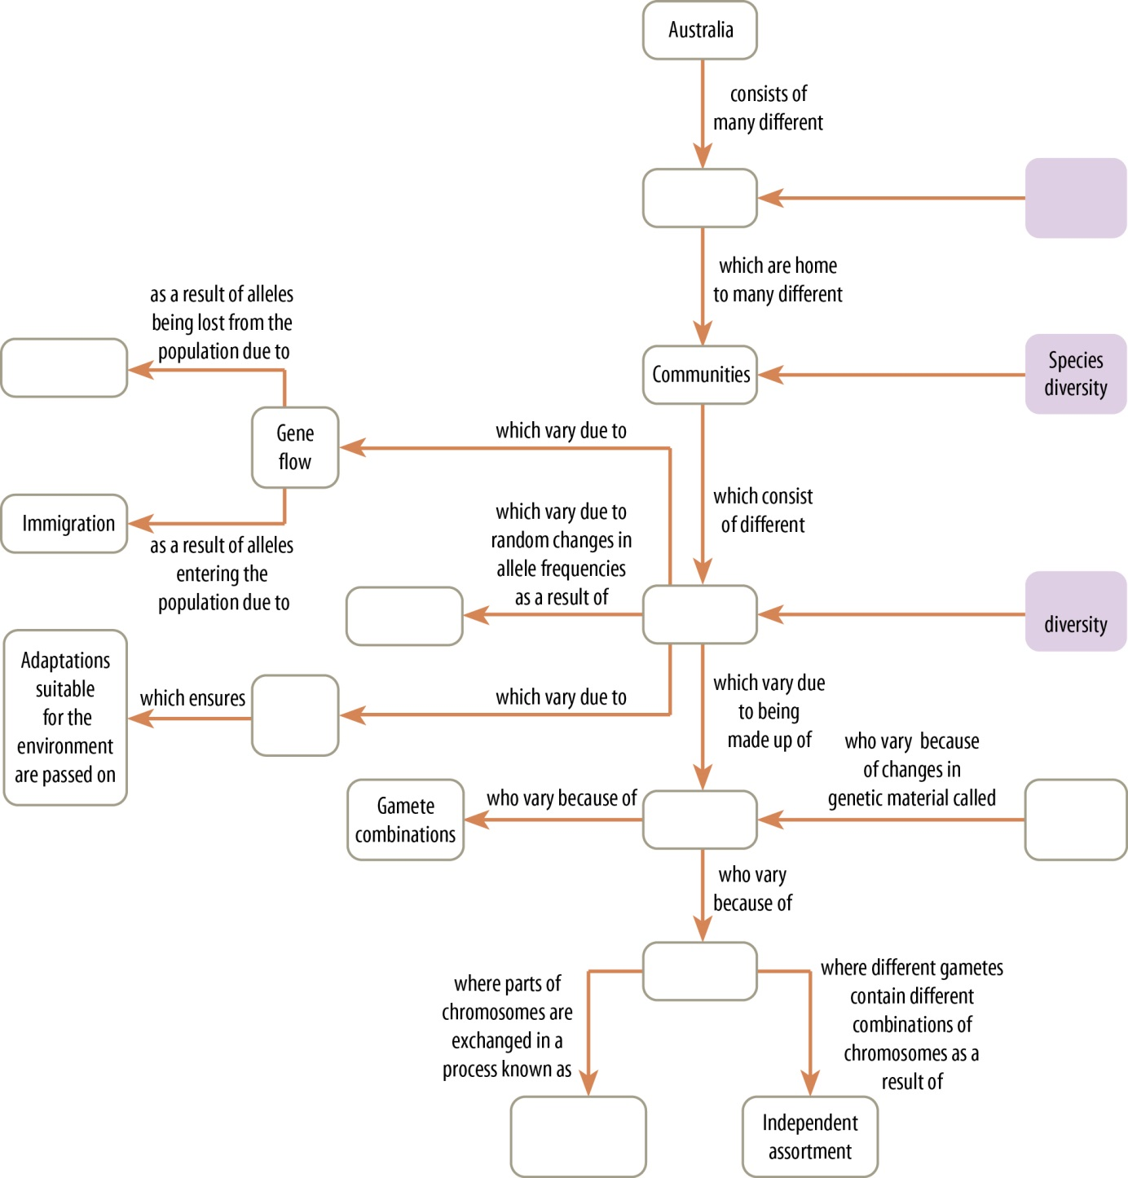

- Compare and contrast the impact of environmental change and reproductive technology on biodiversity by listing their similarities and differences in the table below.

Similarities | Differences

- The term ‘speciation’ refers to the process in which two or more populations of a single species develop into separate species. This is a complex process that can be summarised by the key points set out below. These points are not shown in the order in which they occur. Write down the letter corresponding to each step in the correct order.
 | ........ |  | A | Random mutation, natural selection and a long period of time result in the two groups becoming increasingly adapted to their particular environments and increasingly different to one another.
 | ........ |  | B | Speciation has occurred, resulting in two species.
 | ........ |  | C | The two groups are isolated from one another so breeding between the two groups ceases.
 | ........ |  | D | A single group of organisms within a particular species splits into two separate populations.
 | ........ |  | E | One population migrates to a different habitat that exerts environmental pressures different to those experienced by the original population.
 | ........ |  | F | Eventually, members of the two populations become so different from one another that they are no longer able to interbreed, even if brought back together again.

- Identify the selection pressures that act to drive evolution and speciation.
.......................................................................................................................................................................................................................................................................................................................................................................................................................................................................................

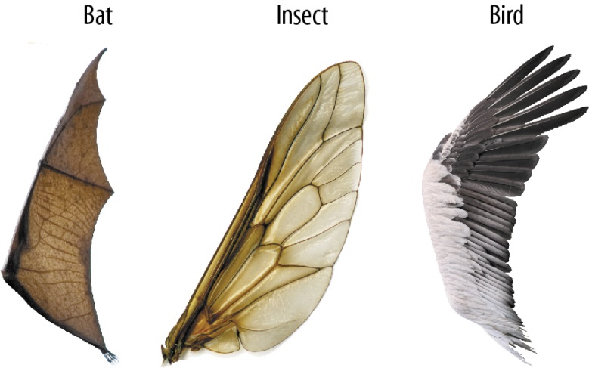

- Are the images above examples of convergent or divergent evolution? Give a reason for your answer.
..............................................................................................................................................................................................................................................................................................................

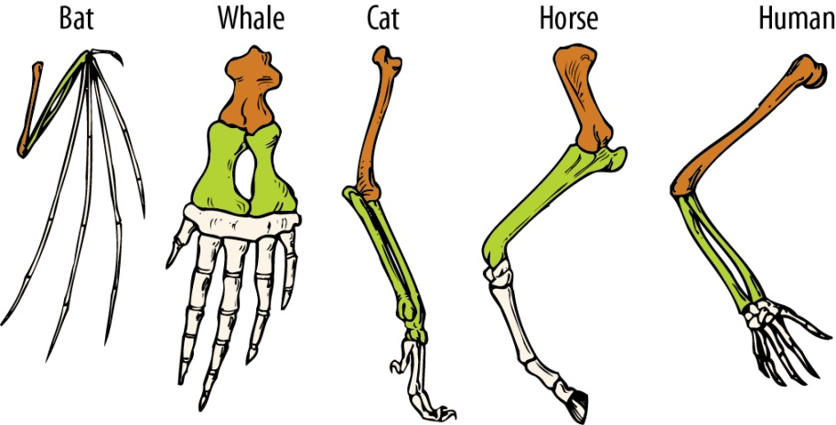

- Are the images above examples of convergent or divergent evolution? Give a reason for your answer.
..............................................................................................................................................................................................................................................................................................................

- Complete the following sentences to explain how comparative anatomy is used to provide evidence of convergent and divergent evolution.

Comparative anatomy involves comparing the ......... structures of different organisms. Similar bone structures are referred to as .................... structures and are seen to be evidence of a ............... ancestor. Homologous structures provide evidence of ................. evolution as they have similar organisation but often have different .................. in species as a result of different ................... pressures. An example of a homologous structure is the ................ limb found in mammals.

Similar features present in .................. animals are referred to as .................. structures and result from similar selection pressures. Analogous structures provide evidence of ..................... evolution because although the final function is the same, the underlying .................. are not. An example would be the wings of ............... (which are invertebrates) and birds (which are .....................).
- Identify the words that correspond with the following definitions; then match the words with their definitions by writing the appropriate letter on the line beside the word.

 | P..................  t.................... | ....... |  | A | The theory that suggests that the Earth’s crust is divided into plates that move. It is supported by evidence that many of Australia’s marsupials originated in South America.
 | C..................  a.................... | ....... |  | B | The technique of inferring evolutionary relationships by looking at the presence of fossils and current species of animals in relation to geographical regions
 | B.................. | ....... |  | C | Traces of organisms that lived in a previous geological age
 | A.................  d................... | ....... |  | D | The technique of working out the age of fossils by looking at their position in rock layers as well as referring to index fossils
 | R..................  d.................... | ....... |  | E | The technique of working out the age of fossils by looking at the decay of radioisotopes
 | M.................  b.................... | ....... |  | F | The technique of inferring evolutionary relationships by studying the presence of similar features during the development of embryos
 | C..................  e.................... | ....... |  | G | The technique for establishing evolutionary relationships by comparing bone structures
 | F.................. | ....... |  | H | The technique used to establish evolutionary relationships through the sequencing of DNA or proteins

- Name the different forms that fossils can take and explain the features of each.
..................................................................................................................................................................................................................................................................................................................................................................................................................................................................................................................................................................................................................................................................................................................................................................................................................................................................................................................................................................................................................................................................................................................................................................................................................................................................................................................................................................................................................................................................................................................................................................................................................................

- Use the diagram below to answer the following questions.

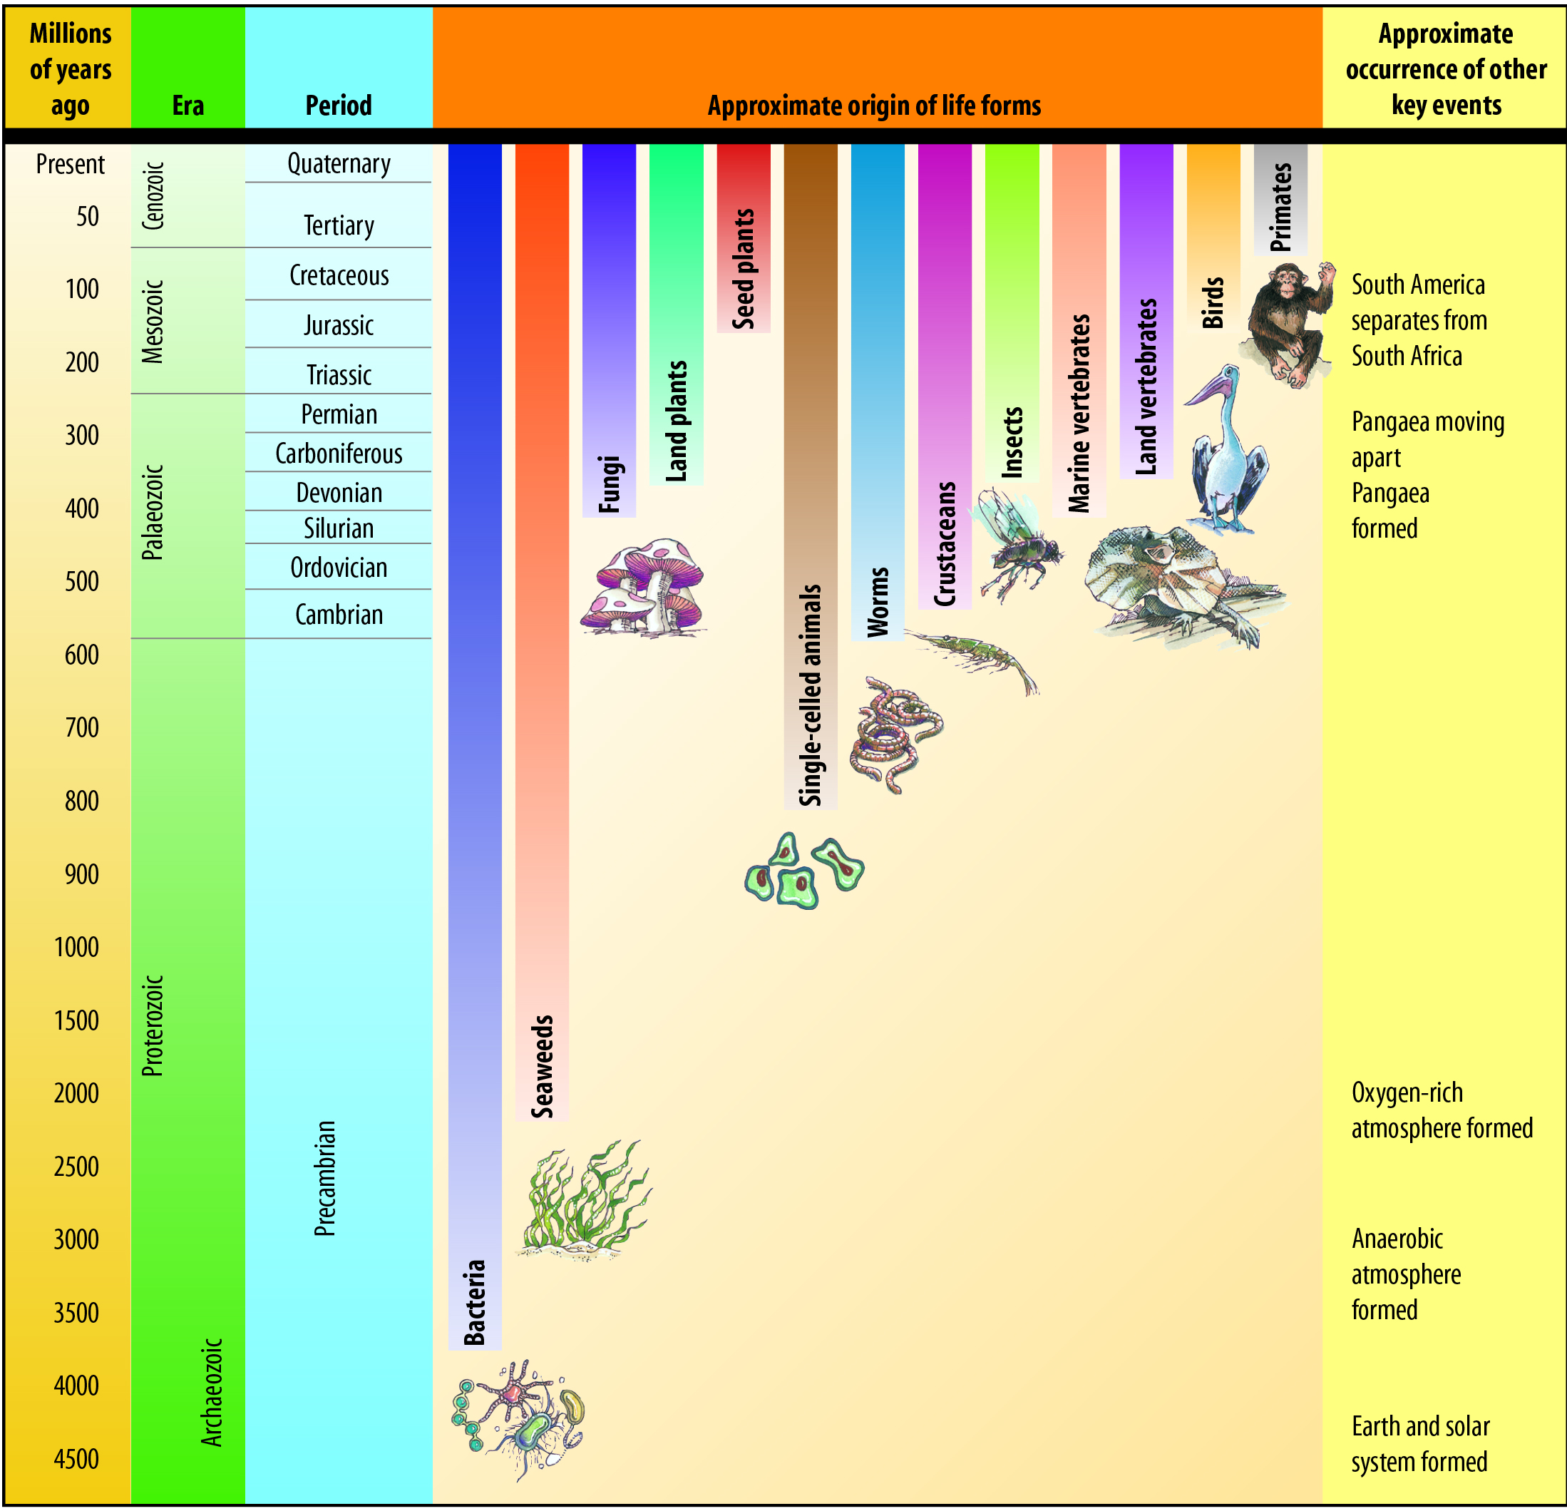

- In which period were fossils of land plants first found?
..................................................................................................
- In which period were fossils of marine vertebrates first found?
..................................................................................................
- In which period were fossils of birds first found?
..................................................................................................

- Complete the following diagram by adding the appropriate names.

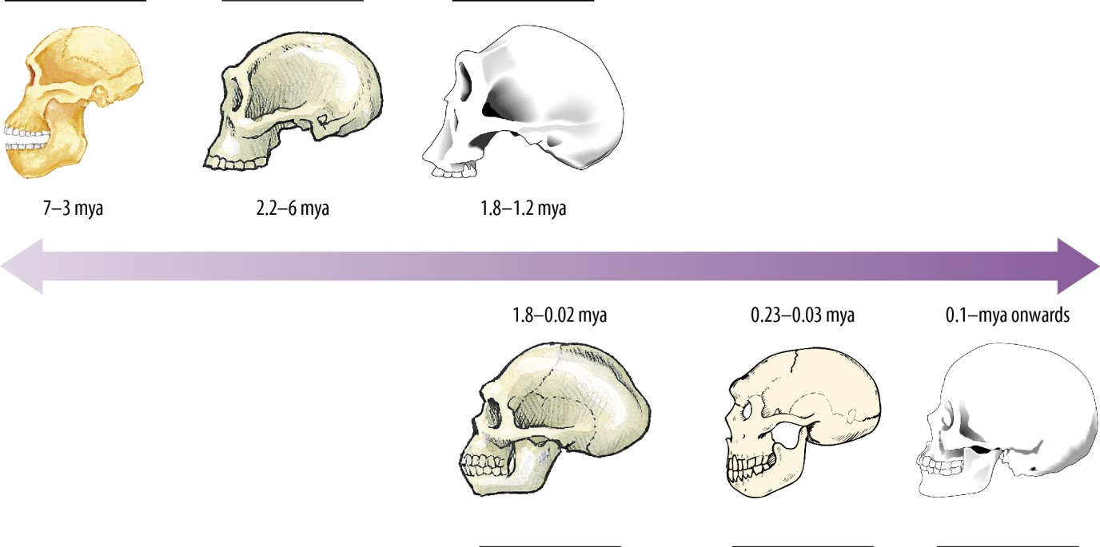

- Hominin is a collective term for various human species and their erect-walking close relatives (species within the genus Homo and the genus Australopithecus). Which skulls represent hominin species that have only been found in Africa?
.............................................................................................................
- Are the faces of skulls generally flatter or more slanted as we travel forward in time?
.............................................................................................................
- Does the size of these skulls generally increase or decrease as we travel forward in time? What can you suggest about brain size as a result of this observation?
.....................................................................................................................................................................................................................................................................................................................................................................................................................................................................

- Name a species that is currently endangered.
...........................................................................
- Why is it endangered?
..............................................................................................................................................................................................................................................................................................................
- What is being done to prevent this species from becoming extinct?
..............................................................................................................................................................................................................................................................................................................

- Revise the key terms in this chapter by completing the following crossword using the clues and words provided.

adaptations | artificial selection | biodiversity | biogeography
cloning | coevolution | common ancestor | competition
convergent | deoxyribonucleic acid | divergent | endemic
evolution | extinct | fossils | gene
gene therapy | hominins | homologous structures | hybrid
inbreeding | introduced | monoculture | mutation
natural selection | palaeontologist | reproductive isolation | selective agent
speciation | species | therapeutic cloning | variation

ACROSS  2 Refers to the differences between individuals of a species as a result of their genetic make-up (9)  4 The struggle between individuals for a share of limited resources such as food, mates, shelter, light (11)  6 Any factor in the environment that affects the survival of an organism (9, 5)  7 The study of living things in relation to geographical regions (12)  11 The term used to describe when two related species have evolved differently enough that they are no longer able to interbreed (12, 9)  13 A species that is brought suddenly into a different ecosystem. This species can change the selection pressures acting on original inhabitants of the ecosystem. (10)  18 A species that has no living members (7)  20 Biological structures that are evidence of shared common ancestry; used as evidence of divergent evolution (10, 10)  22 An individual from which two or more different individuals or species are descended (6, 8)  23 A population of organisms that interbreed with each other to produce fertile offspring (7)  25 The process by which an identical copy of another living organism is produced (7)  26 A species that occurs naturally in, and is restricted to, one particular geographic region (7)  28 Type of evolution where two species that are not closely related evolve separately to have similar adaptations in response to similar environments (10)  29 A change in a DNA sequence or part of a chromosome (8)  30 The formation of a new species (10)  31 The term used to describe humans and extinct human-related species that walked on two legs, as opposed to hominids (the term used to refer to all modern and extinct Great Apes such as modern humans, chimpanzees, gorillas, orang-utans and all their immediate ancestors). (8)  32 The term used to describe breeding within a limited number of related individuals, such that genetic variation is reduced (10) | DOWN  1 Type of evolution that occurs when a population spreads into new areas, encounters different environments and begins to evolve into two or more different species (9)  3 The cloning of adult cells to provide therapies for diseases where an organ or tissue is required (11, 7)  5 The term used to describe a large area planted with a single species. These areas have limited genetic diversity. (11)  8 The structural or behavioural characteristics of a species that help its survival in its environment (11)  9 The evolution of two or more species in response to each other (11)  10 The process of humans selecting which individuals should breed in order to modify species (10, 9)  12 A scientist specialising in the study of fossils (15)  14 The molecule that carries the genetic instruction of all cellular organisms that determines biological characteristics (16, 4)  15 The process of providing a healthy copy of a gene to a patient suffering from a condition caused by a malfunctioning gene (4, 7)  16 Sometimes known as survival of the fittest; refers to the process by which only the organisms best adapted to their environment tend to survive and transmit their genetic characteristics in increasing numbers to succeeding generations, while those less adapted tend to be eliminated (7, 9)  17 The term used to describe the biological variety of ecosystems and species that occur on Earth (12)  19 A change in the inherited characteristics of a group of organisms (9)  21 A section of DNA that carries instructions for production of a protein (4)  24 The type of offspring that results from breeding two different species (6)  27 Remnants of organisms that lived in a previous geological age (7)

